Signing Up for Zoom (For users who did not already have an account prior to 3/1/2020)

1. Go to – <https://xoriant.zoom.us>
2. Click Download Center



1. Download the Zoom Client for Meetings

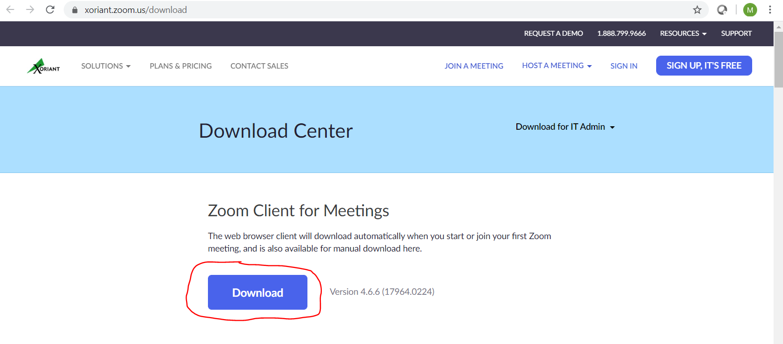

1. Run the ZoomInstaller.exe to install the Zoom Client for Meetings

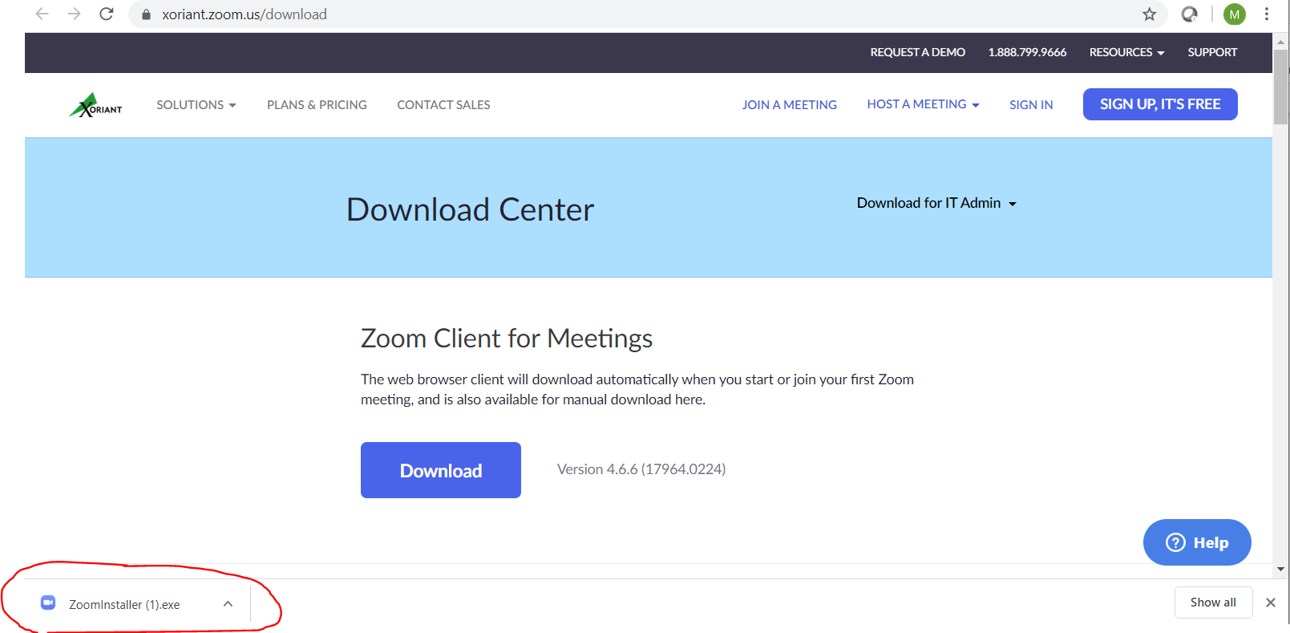

1. Once installed the client should open. Click Sign In.

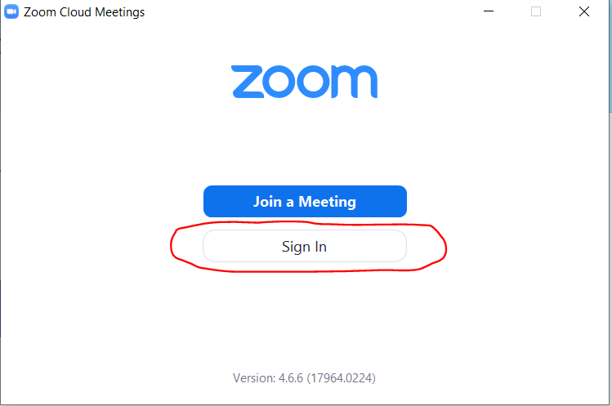

1. Click Sign-In with SSO

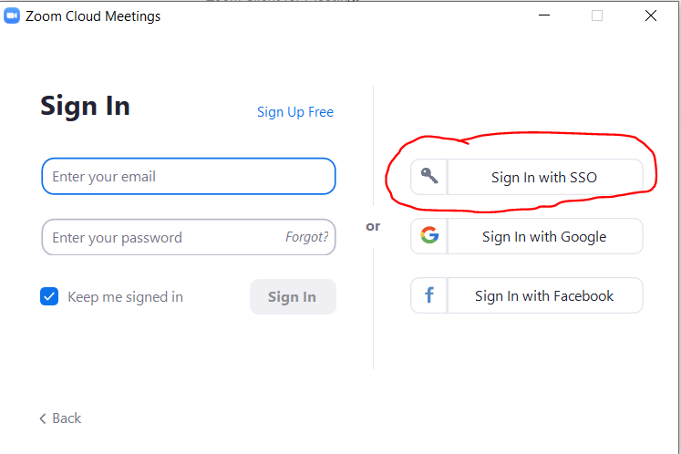

1. Enter xoriant for company domain and click continue.

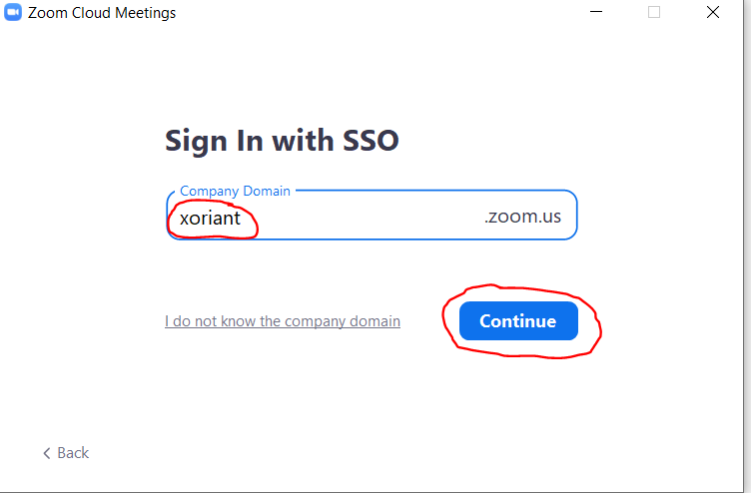

1. You should receive the Xoriant ADFS Login. Login with your domain credentials (same as email credentials)

Example - XOR-IND\abanave_a ( Your Xoriant Login ID )



1. After successfully logging in you will get the following page. The Zoom App should launch on its own or you may have to click Open Zoom Meetings

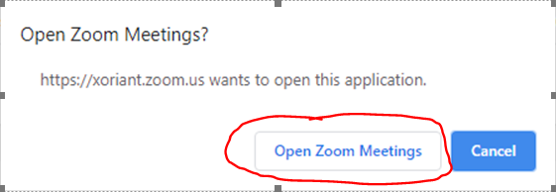

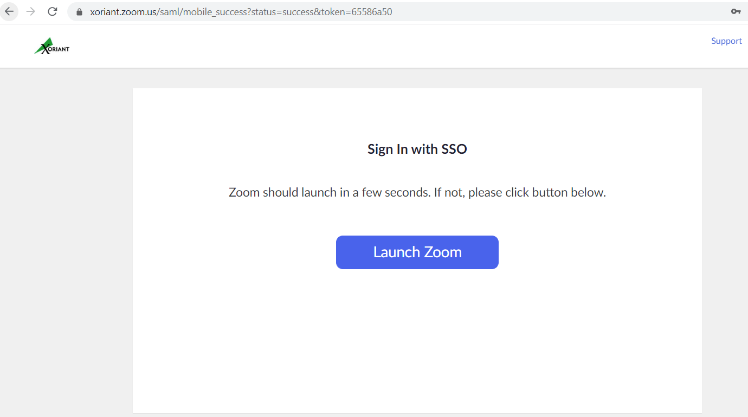

Zoom App

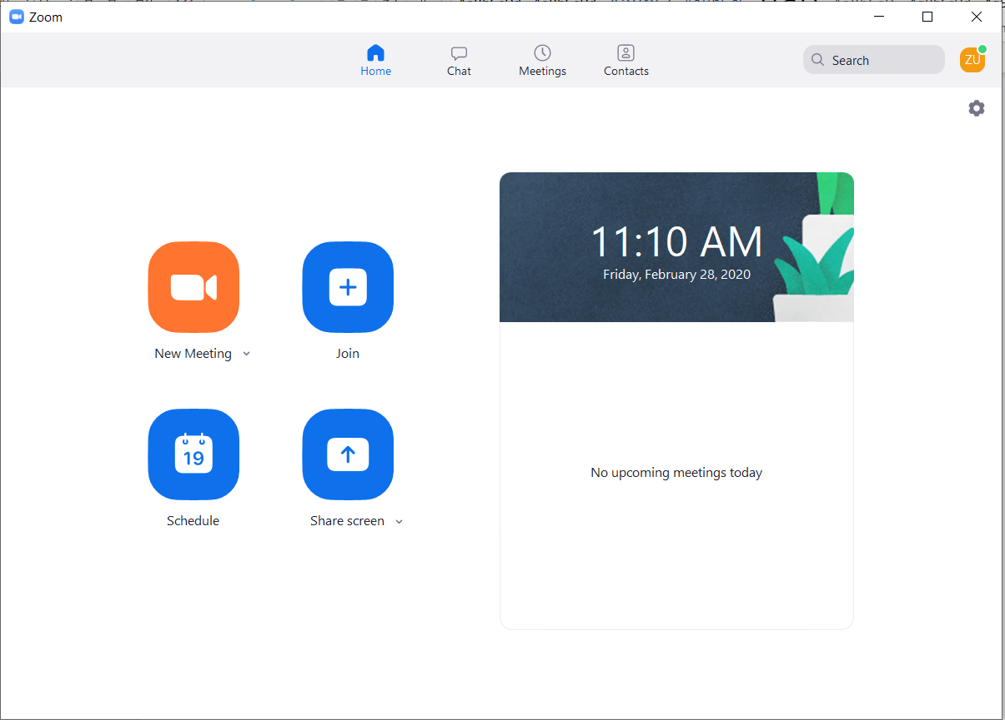

1. Click on Settings

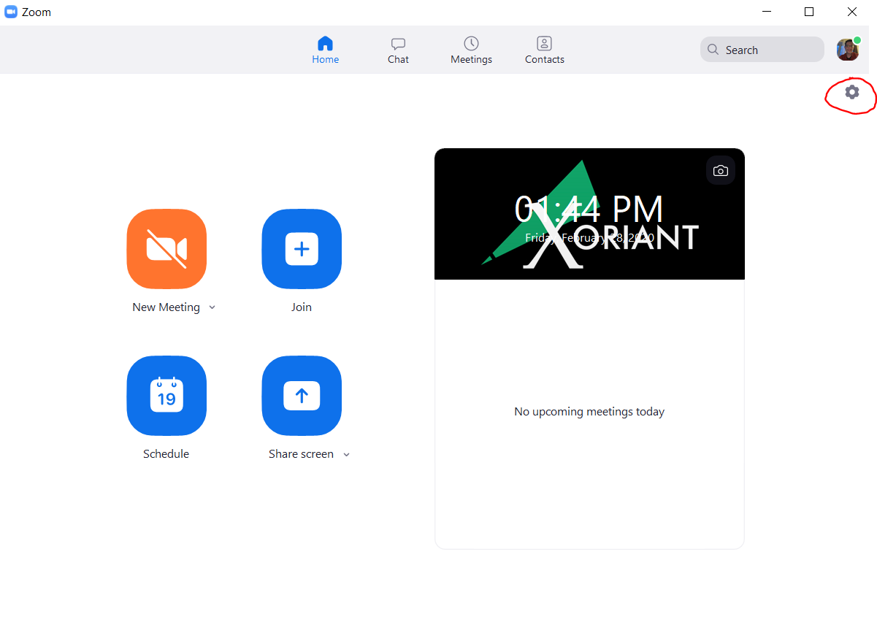

1. General Tab – Check Start Zoom when I start Windows

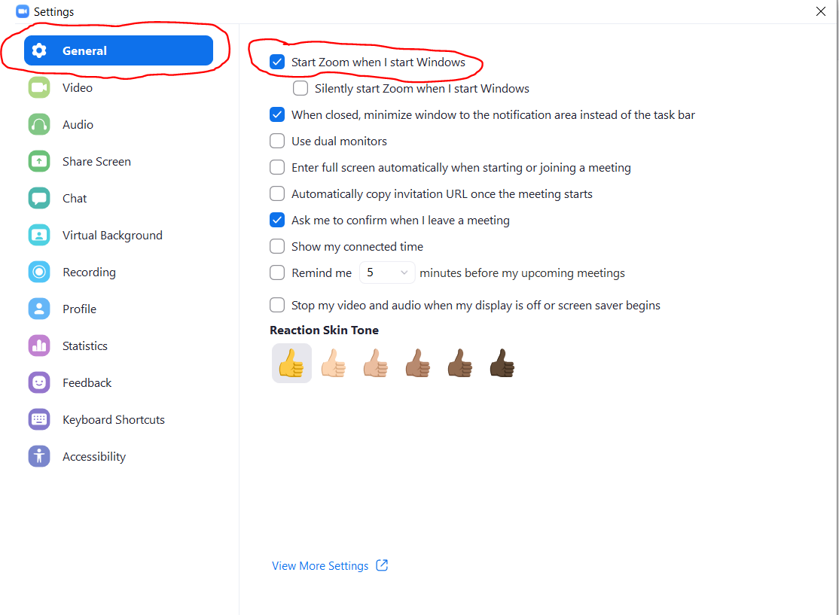

1. Going forward, to launch the Zoom Desktop App, you can click on the desktop shortcut

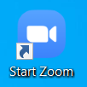

If you get signed out, then repeat the sign-in process





